Table of Contents

1.0 INTRODUCTION 2

2.0 ADMIN 3

2.1 CLASSIFICATION 3

2.1.1 ADD 4

2.2 GIS 6

2.2.1 AREA 6

2.2.1.1 ADD 7

2.2.2 GIS MAPS 9

2.2.2.1 ADD 10

2.3 ACCESS CONTROL 12

2.3.1 SM UNIT 12

2.3.1.1 ADD 13

2.3.2 ROLE AND PERMISSION 15

2.2.2.1 ADD 16

2.3.3 USER 18

2.2.2.1 ADD 19

2.4 IMPORT 21

2.5 EXPORT 23

2.6 GENERATE REPORT 26

2.2.2.1 GENERATE REPORT 27

2.7 SCRIPT 31

2.2.2.1 ADD 32

2.8 AUDIT TRAIL 34

2.9 RESOURCE 37

2.2.2.1 ADD 38

# 1.0 INTRODUCTION

The Modern Statistics (MauStats) Platform is developed as a web-based platform with a central database to ensure consistency, security, and accessibility. The platform will help to automate and integrate the data lifecycle from acquisition to dissemination using the Generic Statistical Business Process Model (GSBPM) framework. The platform complies with managing data requirements for Census, SEE, SBR, Demography, and Trade processed data in this phase. It is also feasible for data integration based on SM requirements. This web-based platform consists of two applications – User Interface and Data Management System (DMS).

In this user guide, we will be learning how to use the **Admin** module of the DMS application. The **Admin** module encompasses nine submodules, each of which is designed to oversee specific tasks: **Classification, GIS, Access Control, Import, Export, Generate Report, Script, Audit Trail, and Resource.**

The below section explains the features and steps of using the **Admin** module.

# 2.0 ADMIN

The **Admin** module allows authorized users to manage the core and foundational elements of the platform The **Admin** module encompasses nine submodules: **Classification, GIS, Access Control, Import, Export, Generate Report, Script, Audit Trail, and Resource.**

Let us learn how to use these submodules in detail.

## **2.1 CLASSIFICATION**

This submodule allows authorized users to manage the master list of **Classification**s grouped by type.

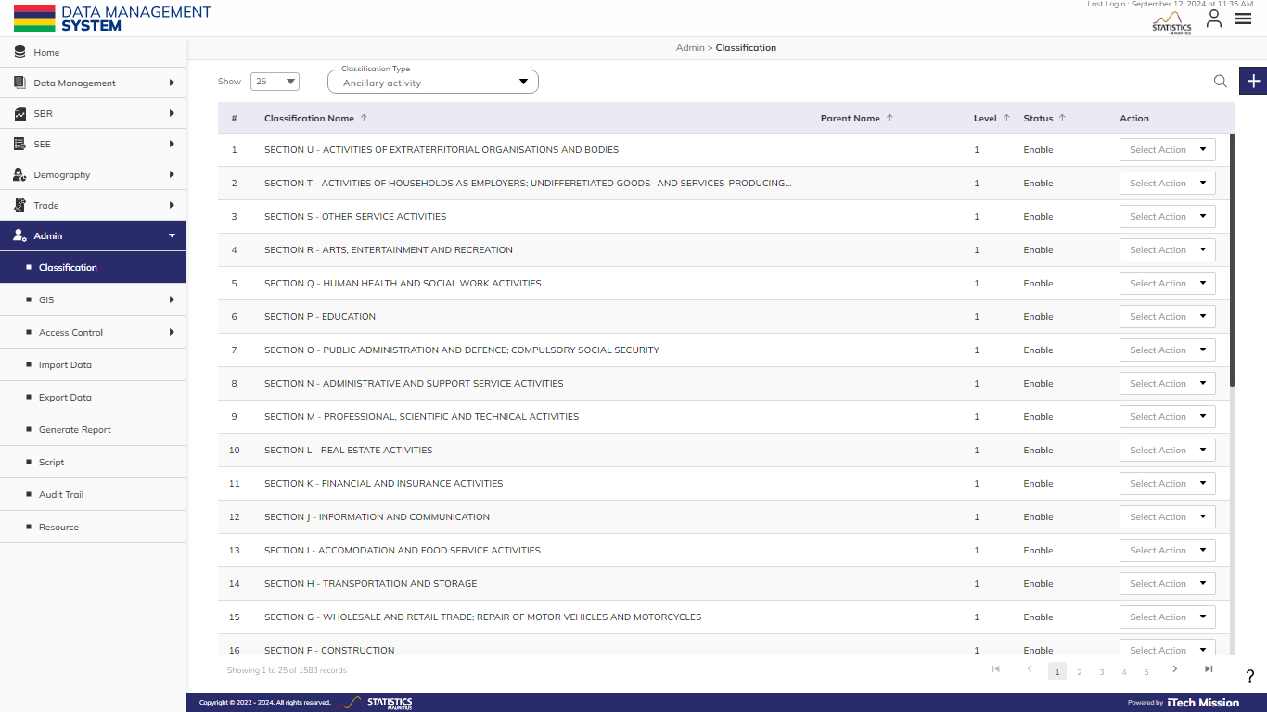**Step 1:** Click on the **Classification** option available under **Admin** to access this sub-module. You have the options to add, associate, edit, delete, and enable/disable the **Classification** options of the selected **Classification** type. You also have the option to search, sort, and view the existing records by page (see below figure).

### 2.1.1 ADD

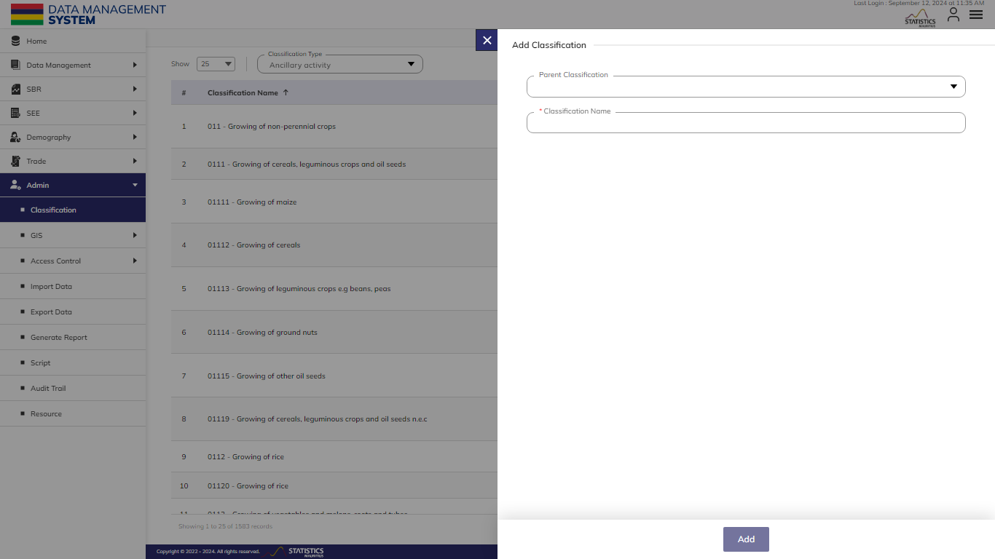**Step 2**: Select the required **Classification Type** and Click the **Plus** button available on the right side of the page to add a new **Classification** (see figure below).

Enter the following details to add a new element–

|  |  |  |  |  |
| --- | --- | --- | --- | --- |
| **Field** | **Type** | **Import Type** | **Mandatory** | **Associated Classification** |
| **Parent Classification** | List | Single Choice | No | List of Parent Name |
| **Classification Name** | Text |  | Yes |  |

Click on the **Add** button to save and confirm. You can now view the new option added to the selected **Classification** type list.

**Step 3:** Selectthe **View** option available in the action dropdown to view the details of the selected element.

**Step 4:** Click the **Search** button and specify the **Classification** name to view entries.

**Step 5:** Select the **Edit** option available in the action dropdown to edit the details of the selected element. Edit the required detail and click on the update button to save and confirm.

**Step 6:** Selectthe **Delete** option available in the action dropdown to delete the selected element. A confirmation popup will appear, click **Yes** to confirm the deletion of the selected element.

**Step 7:** Select the **Enable/Disable** option available in the action dropdown to show or hide the specific element. The hidden element will not be shown in the list of selected **Classification** types overall in the application.

## **2.2 GIS**

The **GIS** module allows to manage the geographical area and their geo-spatial maps in the database. This module has two submodules – **Area** and **GIS** **Maps**.

### 2.2.1 AREA

This submodule allows the authorized users to manage the geographical **Area** hierarchy of Mauritius at national and sub-national levels.

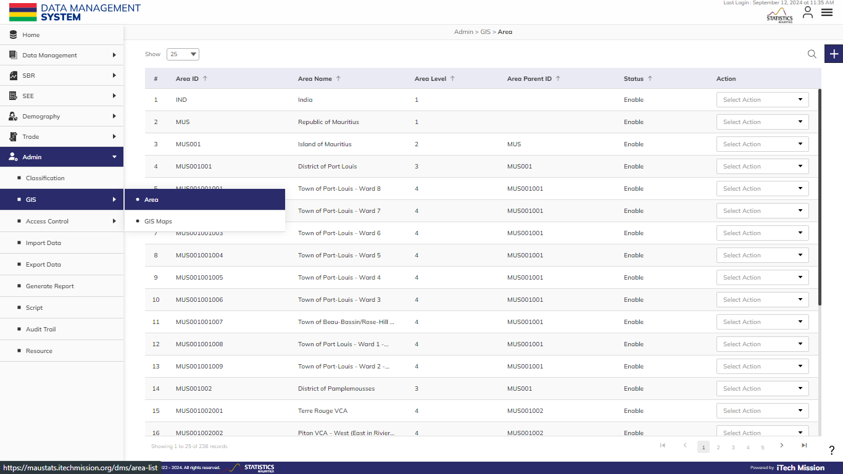**Step 8:** Click on the **Area** option available under the **GIS** of **Admin** to access this sub-module. You have the option to add, edit, delete, and enable/disable the Area options of the selected **Area**. You also have the option to search, sort, and view the existing records (see below figure).



#### 2.2.1.1 ADD

****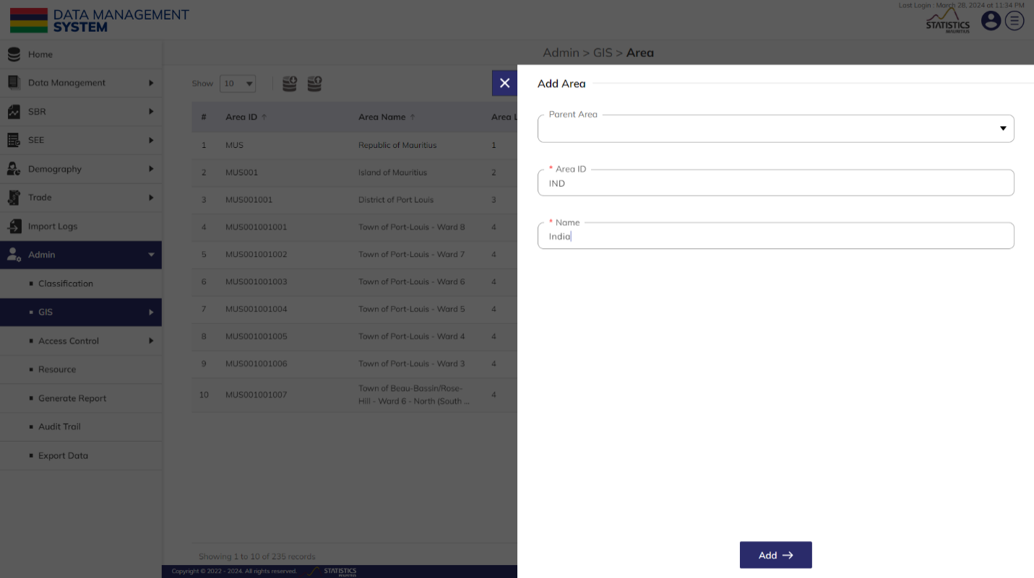**Step 15:** Click the **Plus** button available on the right side of the page to add a new **Area** (see figure below).

Enter the following details to add a new element–

|  |  |  |  |  |
| --- | --- | --- | --- | --- |
| **Field** | **Type** | **Import Type** | **Mandatory** | **Associated Classification** |
| **Parent Area** | List | Single Choice | No | List of Parent Area |
| **Area ID** | Text | Unique | Yes |  |
| Area **Name** | Text | Unique | Yes |  |

Click on the **Add** button to save and confirm. You can now view the new **Area** added to the **Area** list.

**Step 3:** Selectthe **View** option available in the action dropdown to view the details of the selected element.

**Step 4:** Click the **Search** button and specify the name to view entries.

**Step 5:** Select the **Edit** option available in the action dropdown to edit the details of the selected element. Edit the required detail and click on the update button to save and confirm.

**Step 6:** Selectthe **Delete** option available in the action dropdown to delete the selected element. A confirmation popup will appear, click **Yes** to confirm the deletion of the selected element.

**Step 7:** Select the **Enable/Disable** option available in the action dropdown to show or hide the specific element. The hidden element will not be shown in the list of selected Area types overall in the application.

### 2.2.2 GIS MAPS

This submodule allows authorized users to associate and manage the **GIS** **Maps**.

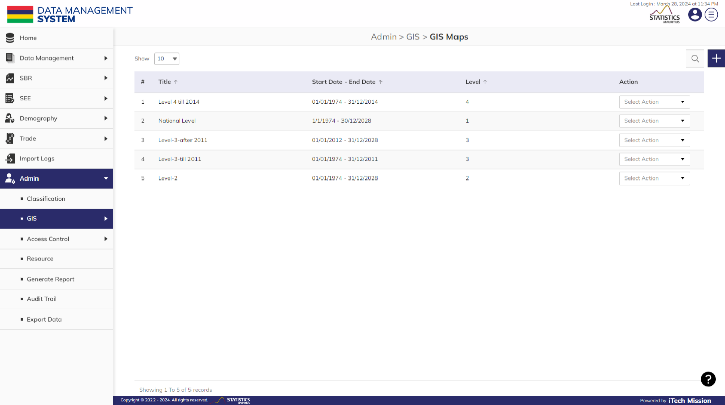**Step 19:** Click on the **GIS Maps** option available under the **GIS** of **Admin** to access this sub-module. You have the option to add, edit, and delete the **GIS** of the selected **GIS Maps**. You also have the option to search, sort, and view the existing records (see below figure).

You have the option to associate/disassociate the maps with the geographical areas and associate multiple maps to the same area with a distinction of start and end date which means that two maps can be associated with a district whose Administrative boundaries have changed over a time period.

#### 2.2.2.1 ADD

****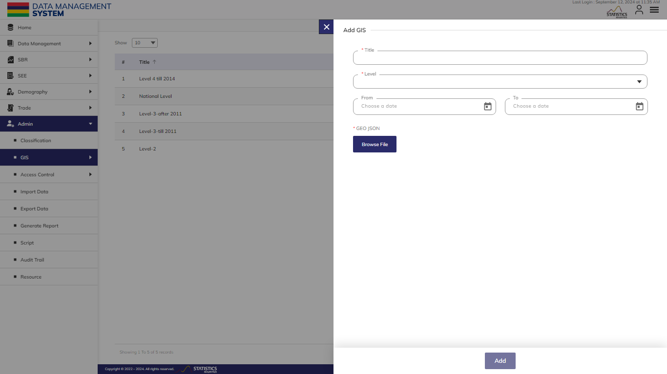**Step 20:** Click the **Plus** button available on the right side of the page to add a new **GIS Map** (see figure below).

Enter the following details to add a new element–

|  |  |  |  |  |
| --- | --- | --- | --- | --- |
| **Field** | **Type** | **Import Type** | **Mandatory** | **Associated Classification** |
| **Title** | Text |  | Yes |  |
| **Level** | List | Single Choice | Yes |  |
| **Start Date** | Date | Format – MM/DD/YYYY while importing | No |  |
| **End Date** | Date | Format – MM/DD/YYYY while importing | No |  |
| **Geo JSON** | File | JSON file | Yes |  |

Click on the **Add** button to save and confirm. You can now view the new **GIS** **Map** added to the list.

**Step 3:** Selectthe **View** option available in the action dropdown to view the details of the selected element.

**Step 4:** Click the **Search** button and specify the name to view entries.

**Step 5:** Select the **Edit** option available in the action dropdown to edit the details of the selected element. Edit the required detail and click on the update button to save and confirm.

**Step 6:** Selectthe **Delete** option available in the action dropdown to delete the selected element. A confirmation popup will appear, click **Yes** to confirm the deletion of the selected element.

## **2.3 ACCESS CONTROL**

The **Access Control** module allows to manage and facilitates the creation and administration of roles, assignment of modules, and configuration of permissions for roles to access the MauStats platform. This module has three submodules – **SM unit**, **Role and Permission**, and **User**.

Let us learn how to use these sub-modules in detail.

### 2.3.1 SM UNIT

This submodule allows authorized users to manage the master list of **SM units** of the platform.

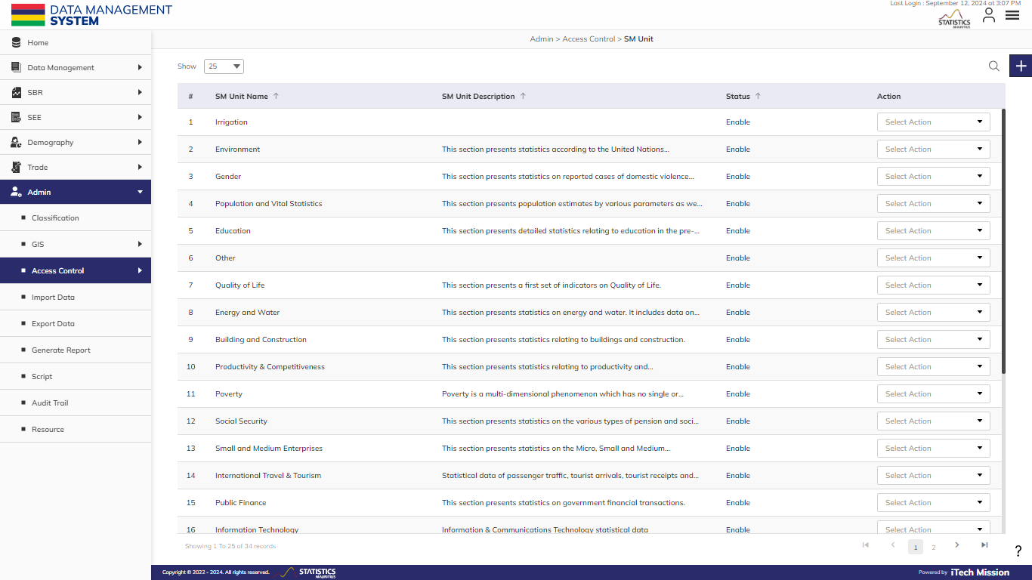**Step 23:** Click on the **SM Unit** option available under the **Access Control** of **Admin** to access this sub-module. You have the option to add, edit, disable/enable, and delete the existing **SM Unit**. You also have the option to search, sort, and view the existing records (see below figure).

#### 2.3.1.1 ADD

****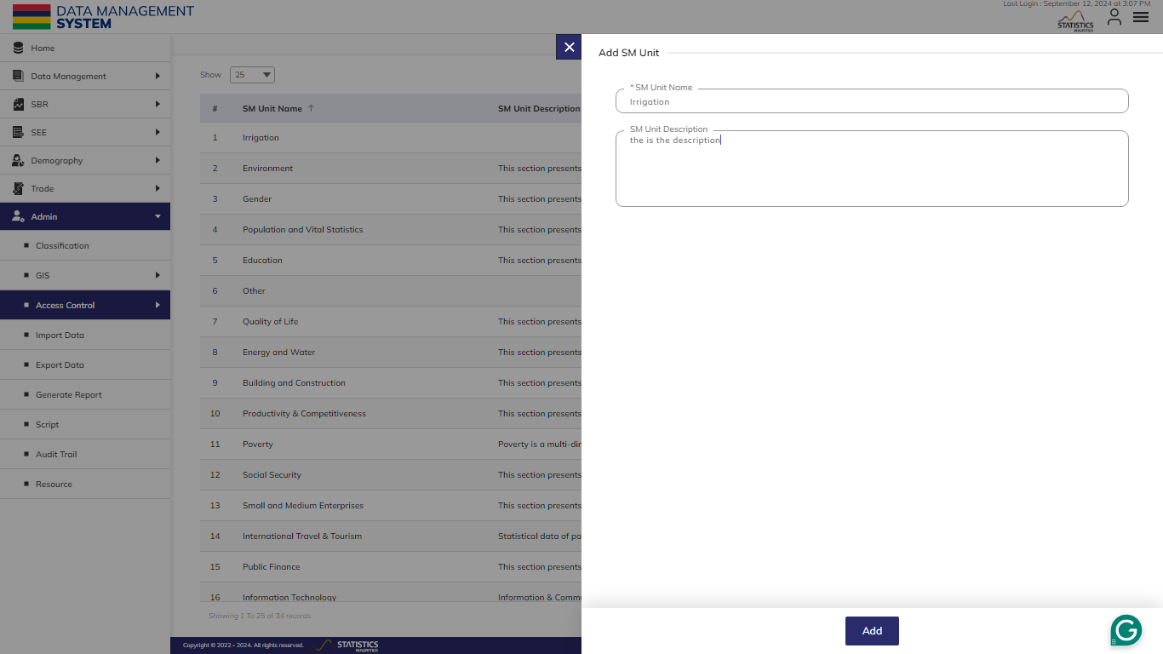**Step 24**: Click the **Plus** button available on the top right corner to add a new SM Unit (see below figure).

Enter the following details to add a new SM Unit–

|  |  |  |  |  |
| --- | --- | --- | --- | --- |
| **Field** | **Type** | **Import Type** | **Mandatory** | **Associated Classification** |
| **SM Unit name** | **Text** |  | **Yes** |  |
| SM Unit description | **Text** |  | **No** |  |

Click on the **Add** button to save and confirm. You can now view the new units added to the SM Unit list.

**Step 3:** Selectthe **View** option available in the action dropdown to view the details of the selected element.

**Step 4:** Click the **Search** button and specify the name to view entries.

**Step 5:** Select the **Edit** option available in the action dropdown to edit the details of the selected element. Edit the required detail and click on the update button to save and confirm.

**Step 6:** Selectthe **Delete** option available in the action dropdown to delete the selected element. A confirmation popup will appear, click **Yes** to confirm the deletion of the selected element.

### 2.3.2 ROLE AND PERMISSION

This submodule allows authorized users to create and manage the user roles of the platform.

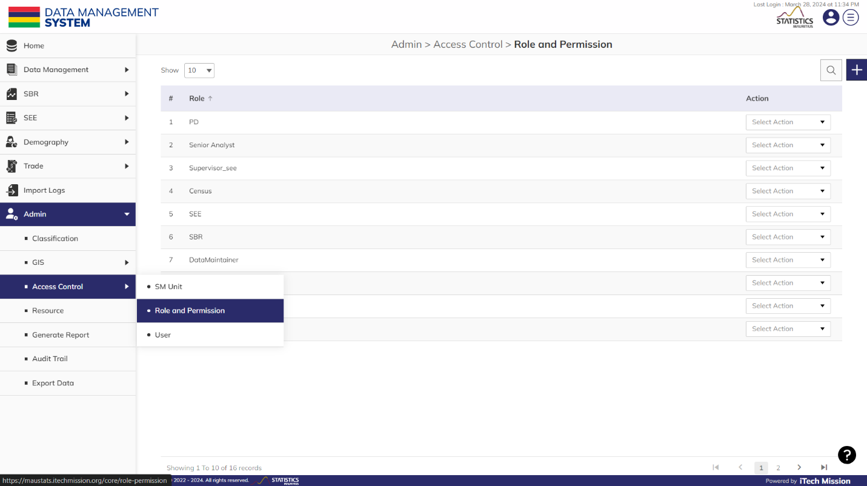**Step 28**: Click on the **Role and Permission** option available under the **Access Control** of **Admin** to access this sub-module. You have options to add, edit, and delete the existing **Role and Permission**. You also have the option to search, sort, and view the existing records (see below figure).

#### 2.2.2.1 ADD

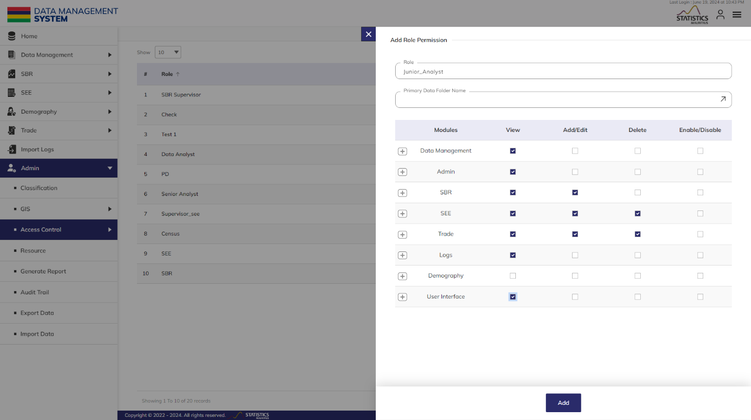**Step 29**: Click the **Plus** button available on the top right corner to add a new user role (see below figure).

Enter the following details to add a new user role–

|  |  |  |  |  |
| --- | --- | --- | --- | --- |
| **Field** | **Type** | **Import Type** | **Mandatory** | **Associated Classification** |
| **Role** | Text |  | Yes |  |
| **Primary Data Folder Name** | List | Multiple Choice | No | Primary Data Folder Name |
| **Permissions** | Checkbox |  | Yes |  |

Click on the **Add** button to save and confirm. You can now view the new user role added in the role and permissions list

**Step 4:** Click the **Search** button and specify the name to view entries.

**Step 3:** Selectthe **View** option available in the action dropdown to view the details of the selected element.

**Step 5:** Select the **Edit** option available in the action dropdown to edit the details of the selected element. Edit the required detail and click on the update button to save and confirm.

**Step 6:** Selectthe **Delete** option available in the action dropdown to delete the selected element. A confirmation popup will appear, click **Yes** to confirm the deletion of the selected element.

### 2.3.3 USER

This submodule allows the authorized users to create and manage the users in the platform of the platform.

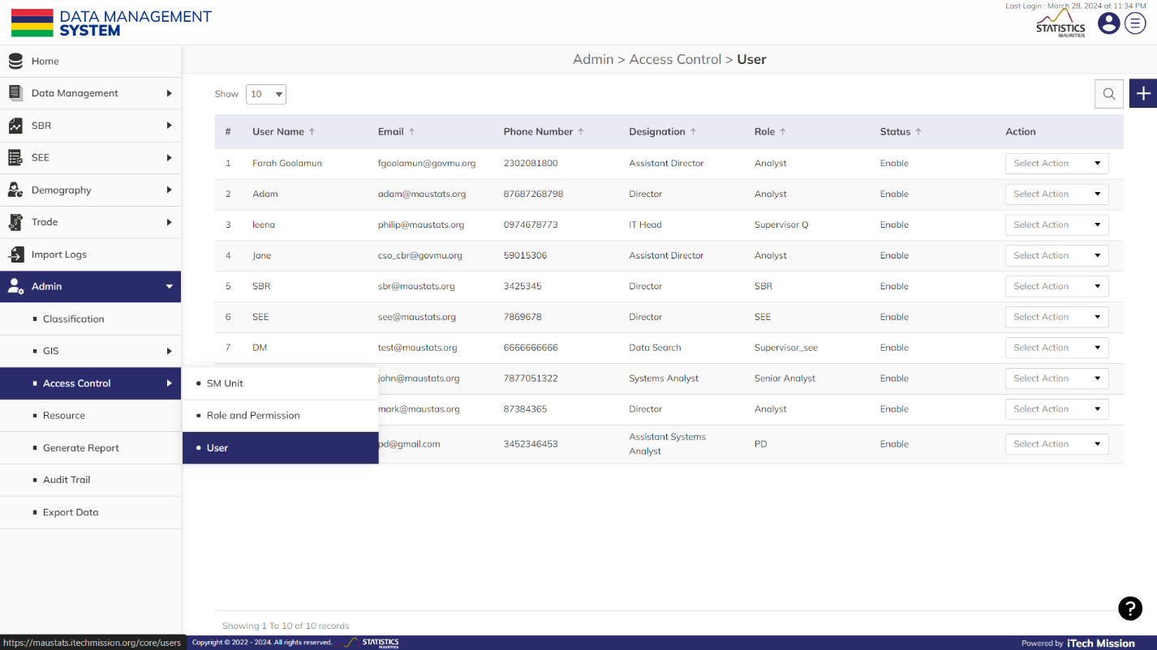**Step 32**: Click on the **User** option available under the **Access Control** of **Admin** to access this sub-module. You have options to add, edit, disable/enable, and delete the existing **User**. You also have the option to search, sort, and view the existing records (see below figure).

#### 2.2.2.1 ADD

****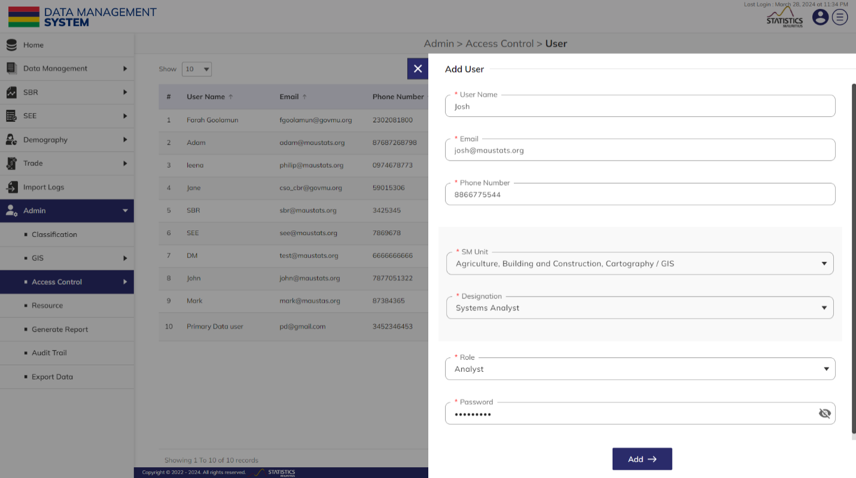**Step 29**: Click the **Plus** button available on the top right corner to add a new user role (see below figure).

Enter the following details to add a new user–

|  |  |  |  |  |
| --- | --- | --- | --- | --- |
| **Field** | **Type** | **Import Type** | **Mandatory** | **Associated Classification** |
| **User Name** | Text |  | Yes |  |
| **Email** | Email |  | Yes |  |
| **Phone Number** | Number |  | Yes |  |
| **SM Unit** | List | Multiple Choice | Yes | SM Unit |
| **Designation** | List | Single Choice | Yes |  |
| **Role** | List | Single Choice | Yes | Role And Permission |
| **Password** | Text |  | Yes |  |

Click on the **Add** button to save and confirm. You can now view the new user added to the user list.

**Step 3:** Selectthe **View** option available in the action dropdown to view the details of the selected element.

**Step 4:** Click the **Search** button and specify the name to view entries.

**Step 5:** Select the **Edit** option available in the action dropdown to edit the details of the selected element. Edit the required detail and click on the update button to save and confirm.

**Step 6:** Selectthe **Delete** option available in the action dropdown to delete the selected element. A confirmation popup will appear, click **Yes** to confirm the deletion of the selected element.

**Step 7:** Select the **Enable/Disable** option available in the action dropdown to show or hide the specific element. The hidden element will not be shown in the list of selected User types overall in the application.

## **2.4 IMPORT**

This submodule allows the **Admin** users to **Import** and upload datasets from their local computer to the MauStats application.

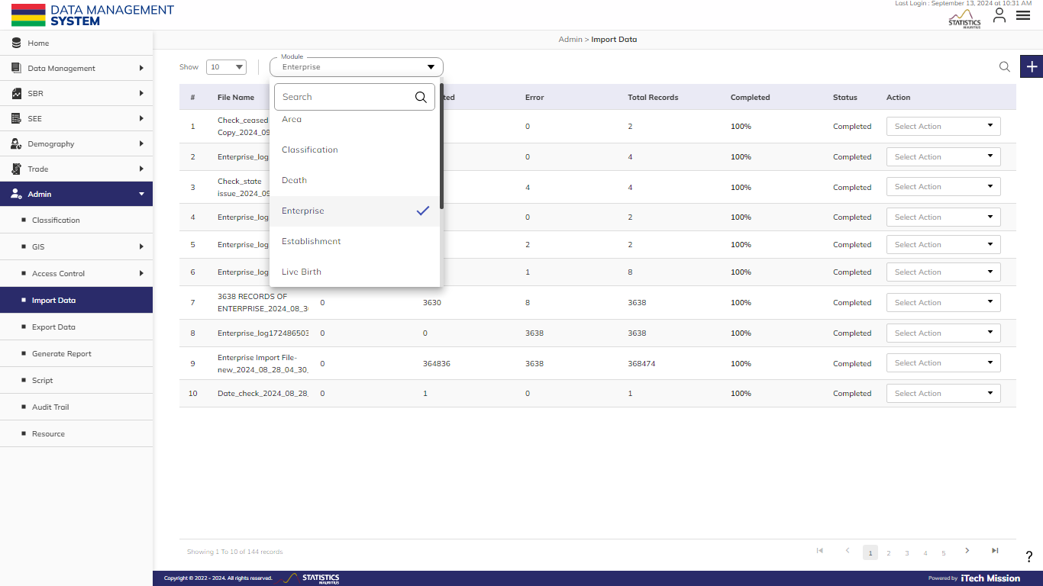**Step 55**: Click on the **Import Data** option available under **Admin** to access this sub-module. Select the module where you want to upload the dataset (see the below figure)

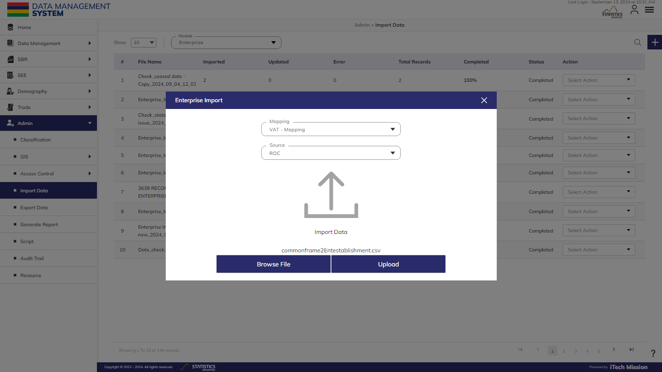**Step 55**: Click on the **Add** button, choose the **Mapping** created for the following module, select **Source** and Browse the .**csv** file then click the **upload** button (see the below figure).

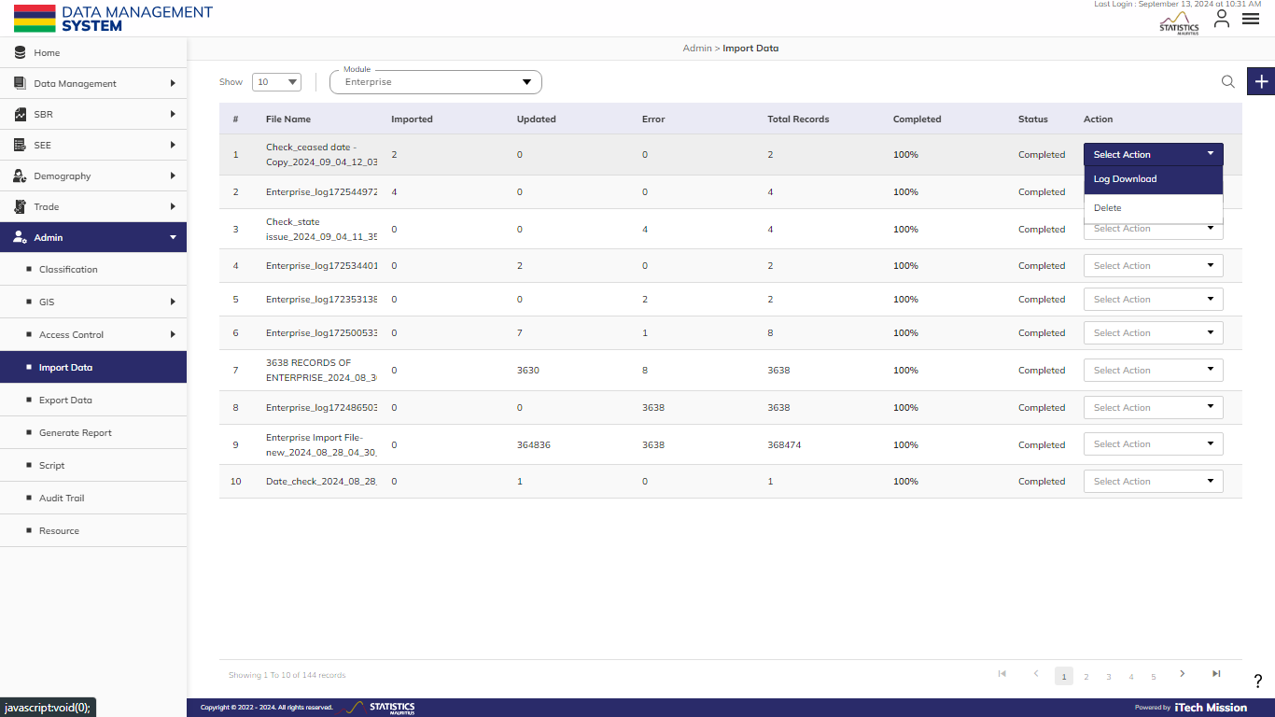**Step 55**: Once the file is uploaded, details such as **File Name, Imported, Updated, Error, Total Records, Completed, and Status** will be visible. You can view the errors that occurred during the Import process by accessing the Log file generated under the Action dropdown. (see the below figure)

## **2.5 EXPORT**

This submodule allows the **Admin** users to **Export** and download the master datasets on their local computer.

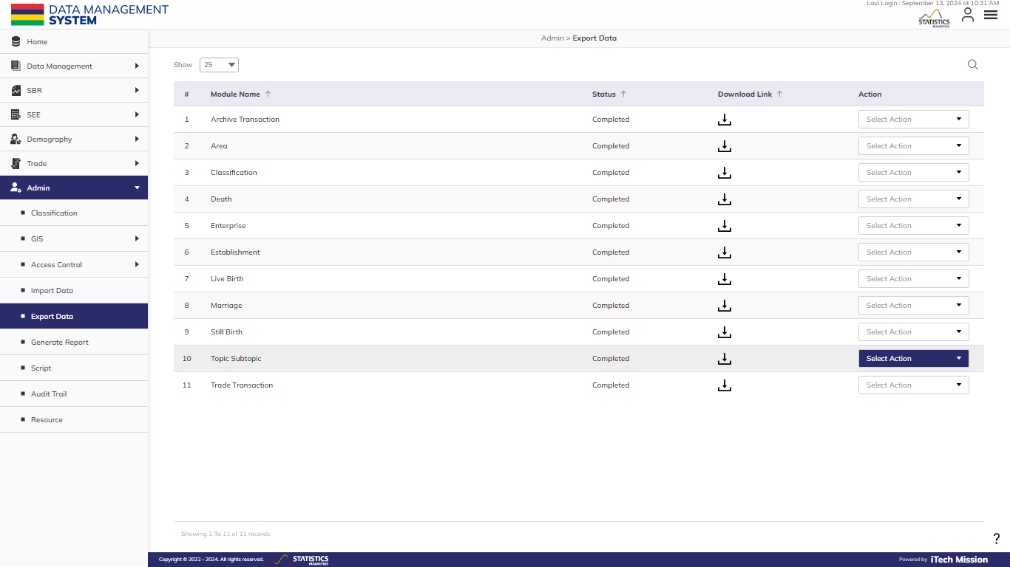**Step 55**: Click on the **Export Data** option available under **Admin** to access this sub-module. You can view the module names present and download the master dataset of each module as a whole or as per the date range. (see the below figure)

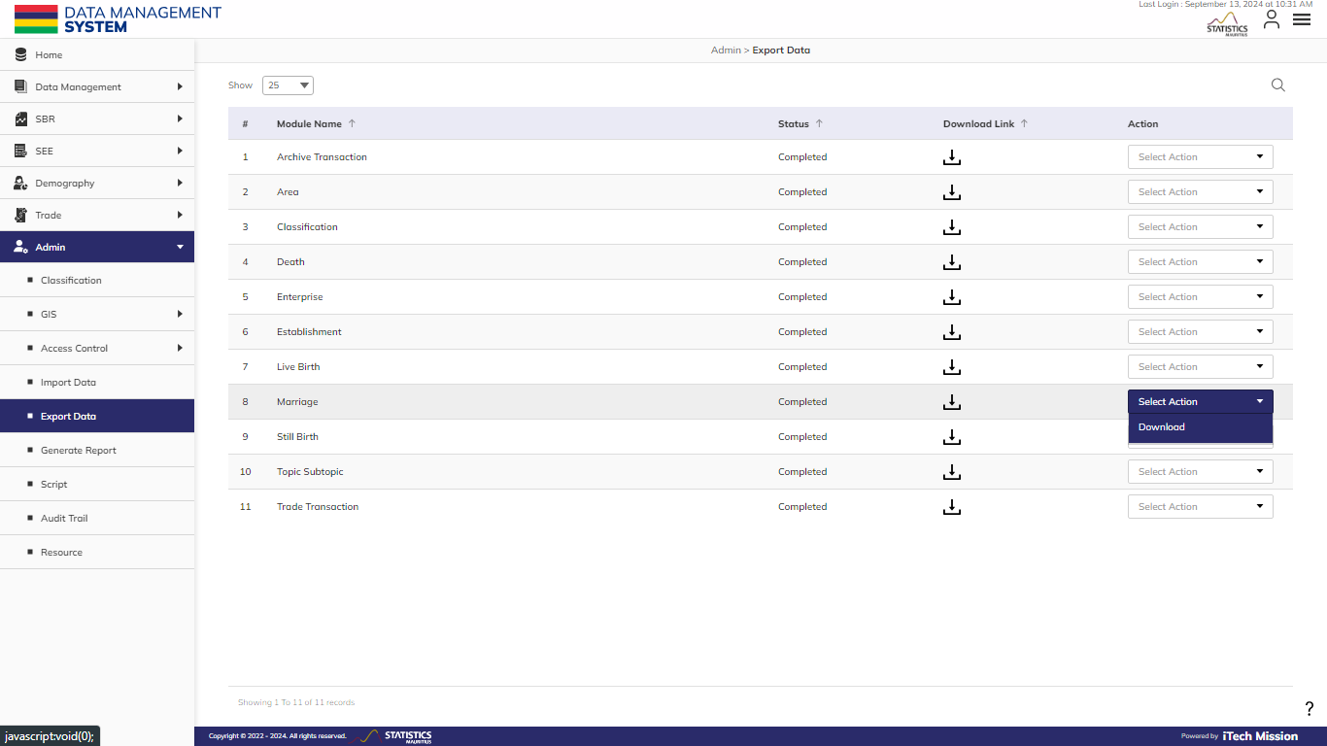**Step 56**: Click to select the **Download** option available in the **Action** dropdown to download the master dataset for the custom date range or master dataset available to date.

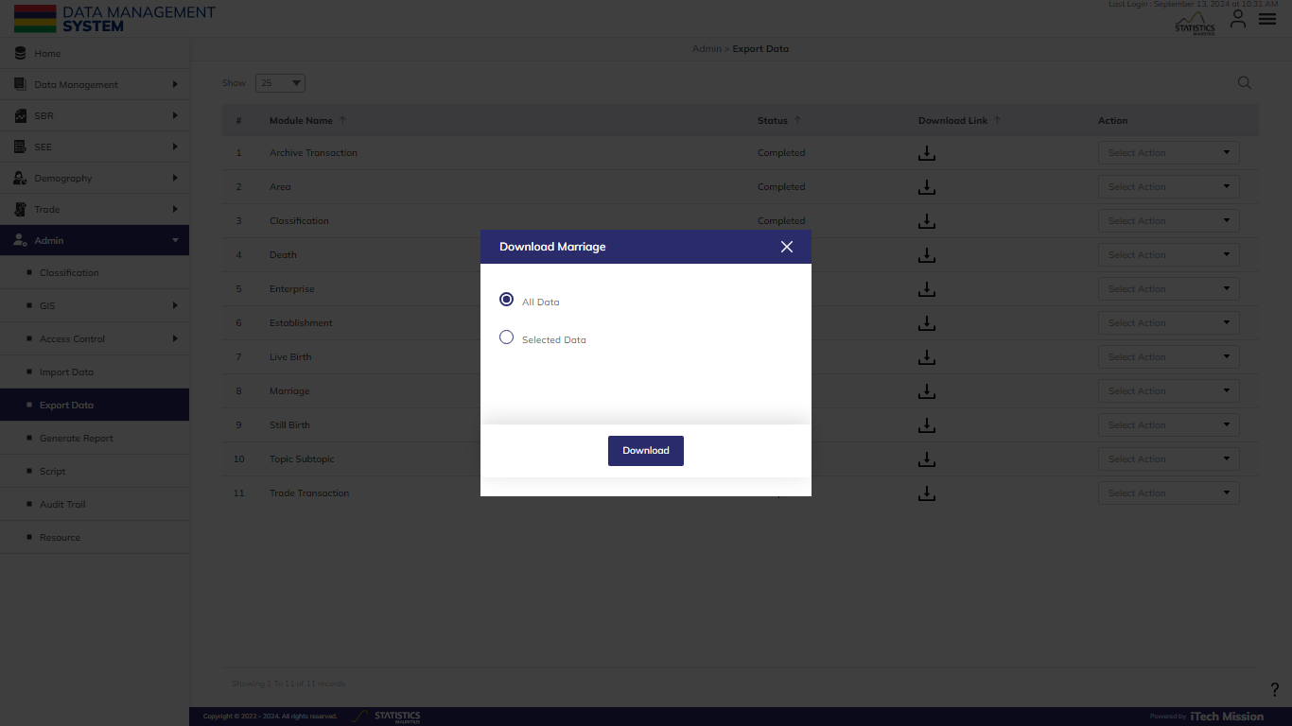**Step 57**: Select one option out of the **All Data** or **Selected Data** and click on the **Download** button. (see the below figure)

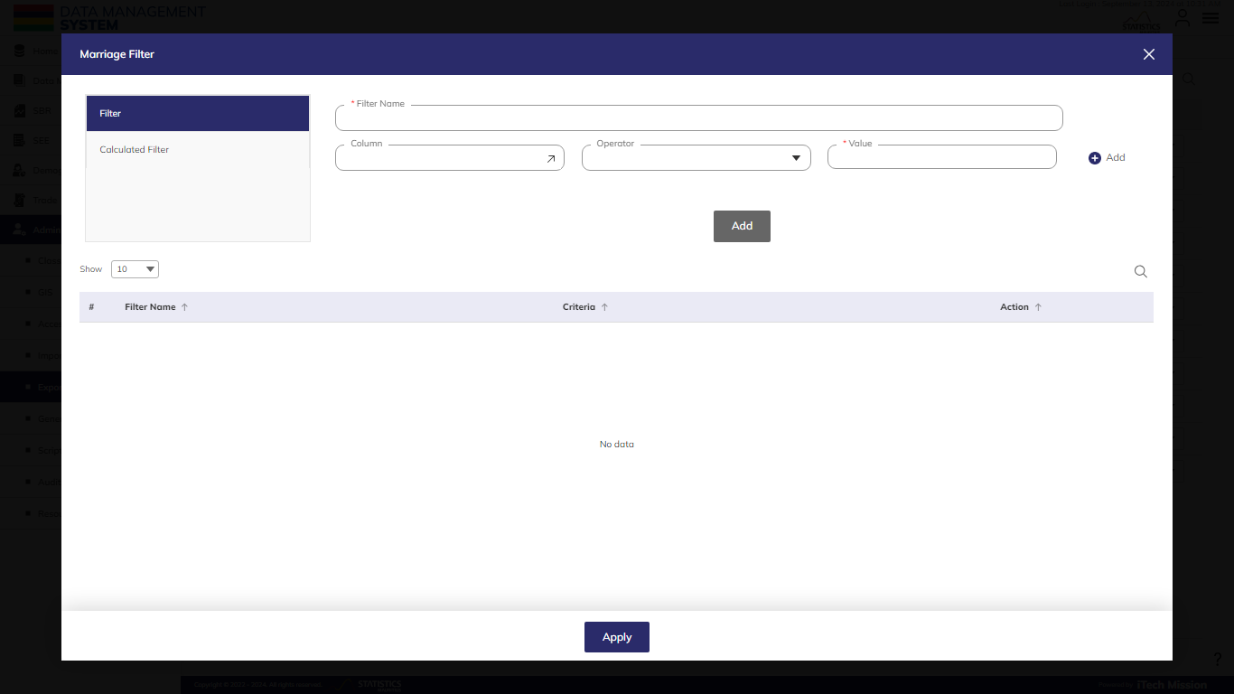**Step 58:** For **Selected Data,** click on the filter button, apply the appropriate filter, and click on the **Download** button. (see the below figure)

## **2.6 GENERATE REPORT**

This submodule allows authorized users to generate reports for a particular date range.

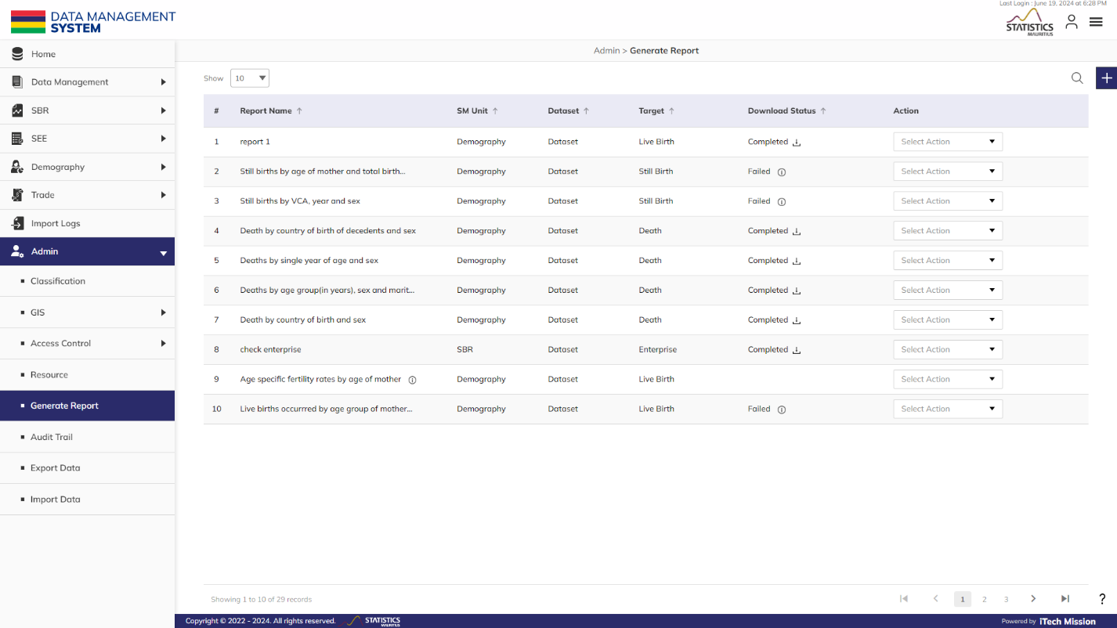**Step 42:** Click on the **Generate Report** option available under **Admin** to access this sub-module. You have the option to edit, delete, and run the existing reports from the list (see below figure).

#### 2.2.2.1 GENERATE REPORT

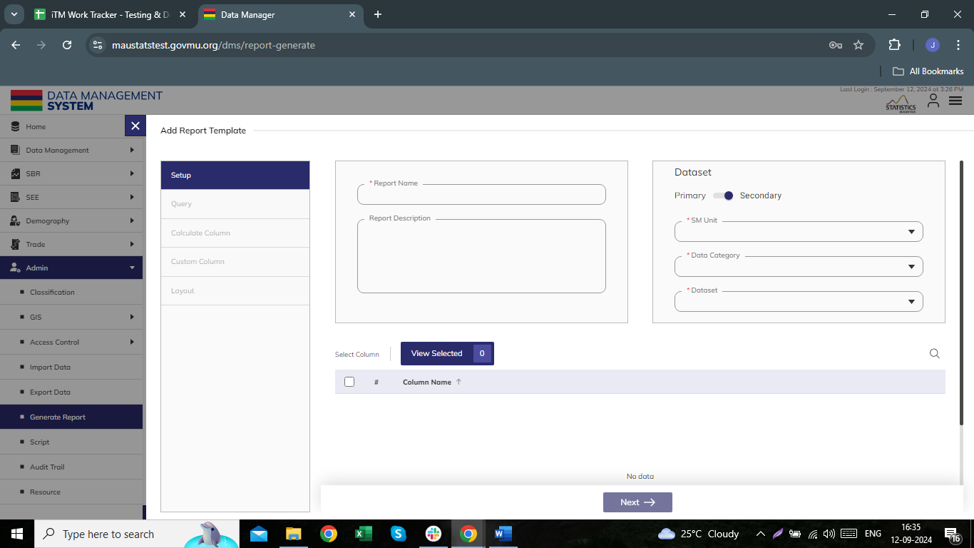**Step 20:** Click the **Plus** button available on the right side of the page to generate a new **Report** **(**see figure below).

The Add **Report** form is divided into sections namely – **Setup**, **Query**, **Calculate**, **Layout**, **Father Information,** and **Address Information**.

**Step 44:** Enter the following information to add a new **Live Birth** record –

|  |  |  |  |  |
| --- | --- | --- | --- | --- |
| **Field** | **Type** | **Import Type** | **Mandatory** | **Associated Classification** |
| **Report Name** |  |  |  |  |
| **Description** |  |  |  |  |
| **Dataset Type** |  | (Primary/Secondary) |  |  |
| **SM Unit** |  |  |  |  |
| **Topic and Subtopic** |  | **(if primary is selected)** |  |  |
| **Files** |  | (if primary is selected) |  |  |
| **Data Category** |  | **(if secondary is selected)** |  |  |
| **Dataset** |  | if secondary is selected) |  |  |
| **Column Names** |  |  |  |  |

**QUERY**

|  |  |  |  |  |
| --- | --- | --- | --- | --- |
| **Filter Name** |  |  |  |  |
| **Column** |  |  |  |  |
| **Level** |  | Associated |  |  |
| **Operator** |  |  |  |  |
| **Value** |  |  |  |  |

**CALCULATE**

|  |  |  |  |  |
| --- | --- | --- | --- | --- |
| **Column** |  |  |  |  |
| **Formula** |  | selecting column from the left column. |  |  |
| **Validate** |  |  |  |  |
| **Decimal Place** |  |  |  |  |

**Conditional Column**

|  |  |  |  |  |
| --- | --- | --- | --- | --- |
| **New Column** |  |  |  |  |
| **Column** |  |  |  |  |
| **Operator** |  |  |  |  |
| **Value** |  |  |  |  |
| **Label** |  |  |  |  |

**Layout**

|  |  |  |  |  |
| --- | --- | --- | --- | --- |
| **Title** |  |  |  |  |
| **Subtitle** |  |  |  |  |
| * Drag and drop **Rows** and **Columns** from the **Rows and Columns** section to **Columns, Rows,** and **Value**. |  |  |  |  |

Click on the **Add** button to save.

**Step 5:** Select the **Edit** option available in the action dropdown to edit the details of the selected element. Edit the required detail and click on the update button to save and confirm.

**Step 6:** Selectthe **Delete** option available in the action dropdown to delete the selected element. A confirmation popup will appear, click **Yes** to confirm the deletion of the selected element.

**Step 51:** Click to selectthe **Execute** option available in the action dropdown to run the report for a particular date range and get the download link of the report. The Data of the report can also be downloaded by clicking the **Download data** checkbox while execution.

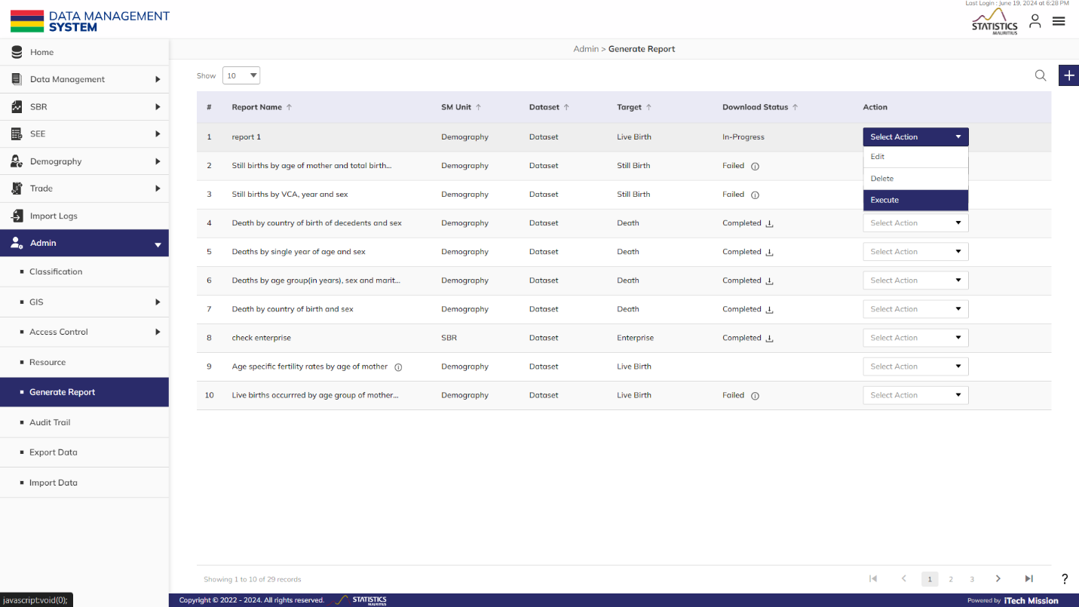**Step 52: Download** the report and data if checked **Download Data** checkbox by clicking on the download icon.

## **2.7 SCRIPT**

This submodule contains **Script** that are compiled with the files of Import and report generated by the Report module outside the MauStats platform to get the desired Report Format.

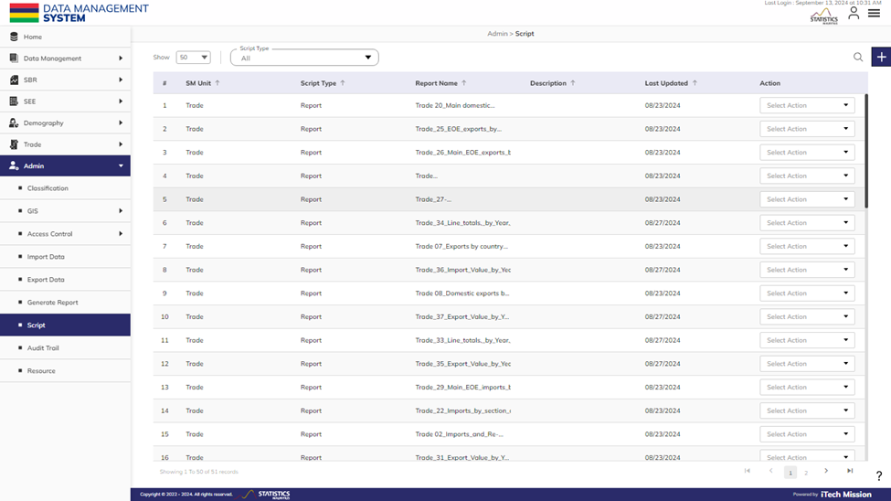**Step 42:** Click on the **Script** option available under **Admin** to access this sub-module. You have the option to add, edit, delete, and download the existing **Script** from the list. You also have the option to search, select Script Type, and sort the existing records (see below figure).

#### 2.2.2.1 ADD

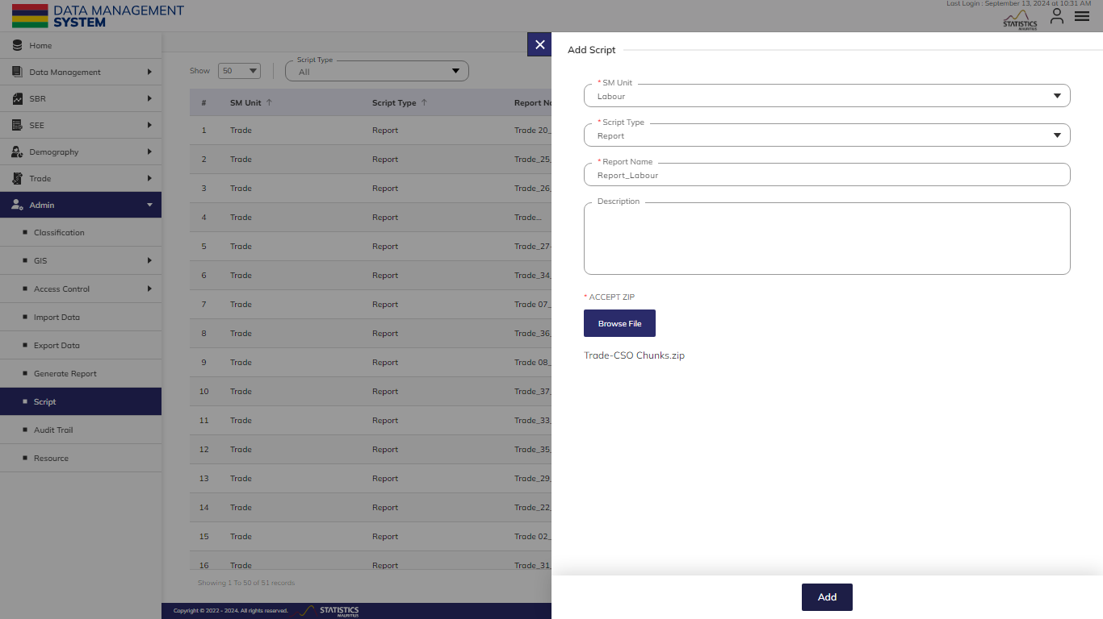**Step 29**: Click the **Plus** button available on the top right corner to add a new user role (see below figure).

Enter the following details to add a new user–

|  |  |  |  |  |
| --- | --- | --- | --- | --- |
| **Field** | **Type** | **Import Type** | **Mandatory** | **Associated Classification** |
| **SM Unit** | List |  | Yes |  |
| **Script Type** | List |  | Yes |  |
| **Report Name** | Text |  | Yes |  |
| **Description** | Text |  | No |  |
| **Accept Zip - Browse File** | File | .zip | Yes |  |

Click on the **Add** button to save and confirm. You can now view the new user added to the user list.

**Step 4:** Click the **Search** button and specify the name to view entries.

**Step 5:** Select the **Edit** option available in the action dropdown to edit the details of the selected element. Edit the required detail and click on the update button to save and confirm.

**Step 6:** Selectthe **Delete** option available in the action dropdown to delete the selected element. A confirmation popup will appear, click **Yes** to confirm the deletion of the selected element.

**Step 7:** Select the **Enable/Disable** option available in the action dropdown to show or hide the specific element. The hidden element will not be shown in the list of selected types overall in the application.

## **2.8 AUDIT TRAIL**

This submodule allows the **Admin** users to track and record all activities and interactions within the platform, providing a comprehensive record of user actions, system events, and changes made in data values.

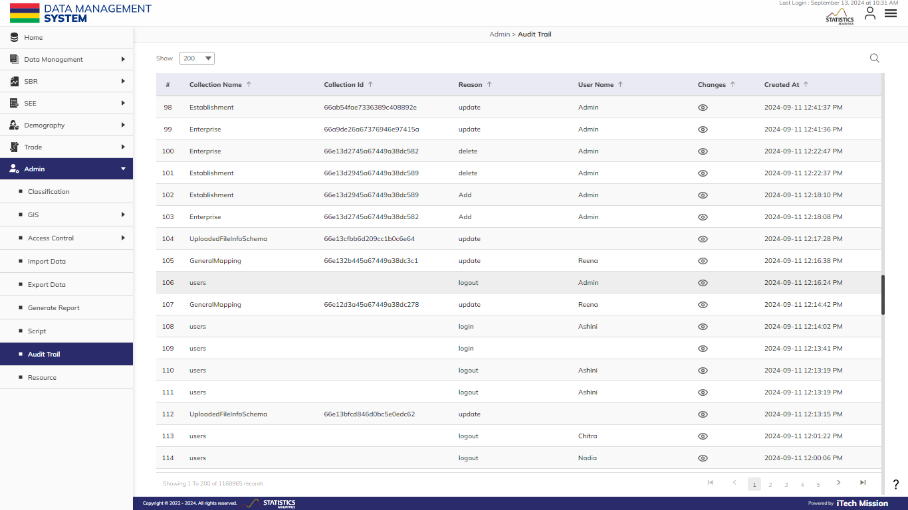**Step 53**: Click on the **Audit Trail** option available under **Admin** to access this sub-module. You will see a chronological list of audit logs. Each log entry provides information about a specific user action or event, including the timestamp and other details of the activity (see below figure).

Each log entry includes the following information –

|  |  |  |
| --- | --- | --- |
| **#** | **Column** | **Definition** |
| **1** | Collection Name | Provides the name of the collection involved in the **Audit Trail** entry. |
| **2** | Collection ID | Specifies the unique identifier (ID) of the collection |
| **3** | Reason | Indicates the nature of the action performed, such as creation, modification, or deletion |
| **4** | User Name | Displays the username associated with the user who acted. |
| **5** | Changes | Allows the option to view the specific modifications or alterations made during the action. |
| **6** | Created At | Represents the timestamp indicating when the audit trail entry was created. |



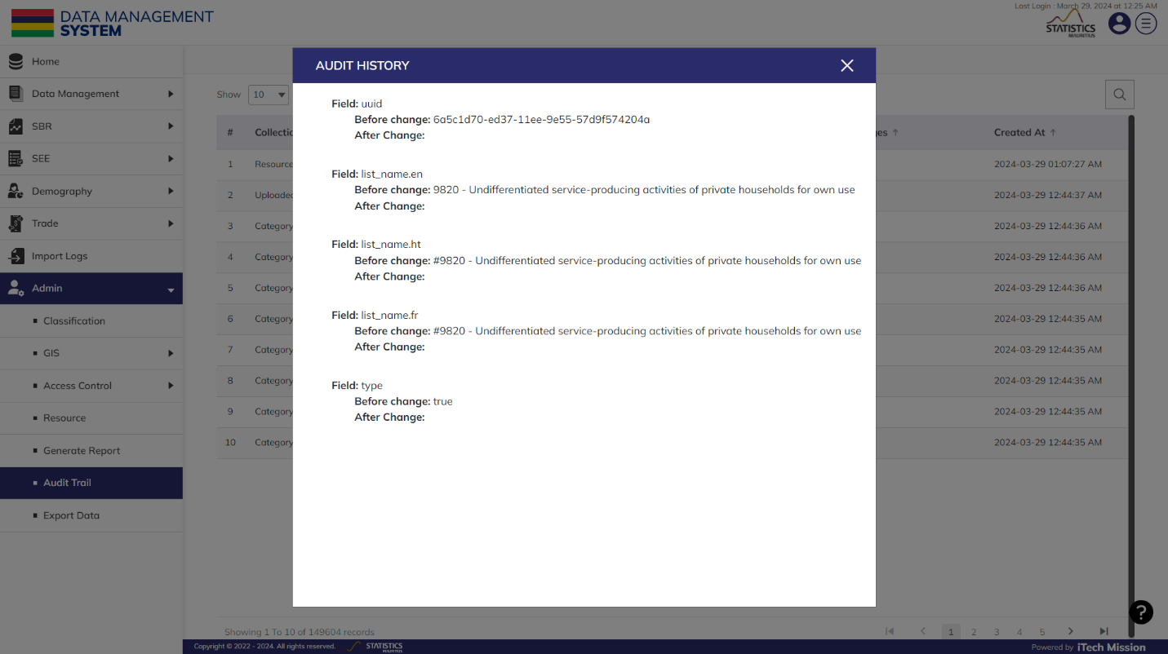**Step 54**: Click on the **Eye** button available under the **Changes** column to view the details of the changes made (see below figure).

You also have the option to **Search** the specific **Audit Trail** and view the **Audit Trail** entries by **Pagination**.

## **2.9 RESOURCE**

This submodule allows authorized users to manage reference materials of the platform.

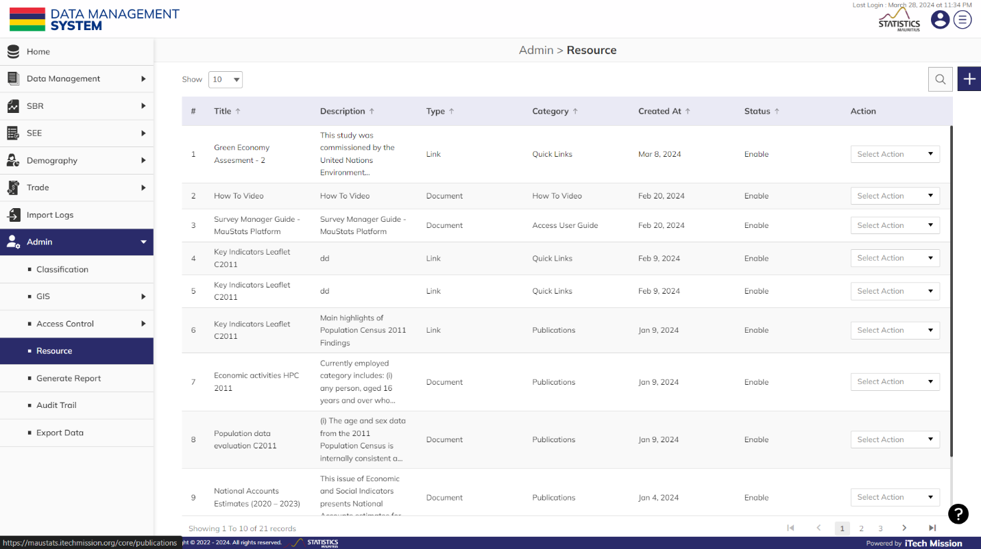**Step 37:** Click on the **Resource** option available under the **Admin** to access this sub-module. You have the option to add, edit, disable/enable, and delete the existing **Resource**. You also have the option to search, sort, and view the existing records (see below figure).

#### 2.2.2.1 ADD

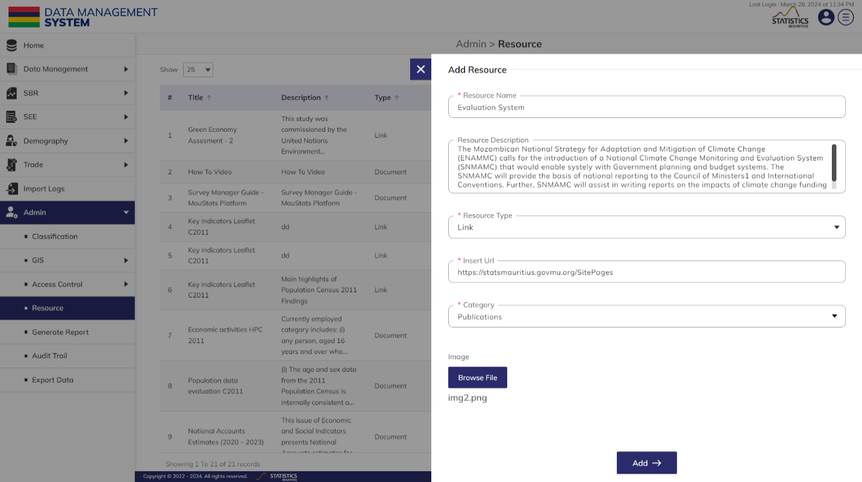**Step 38:** Click the **Plus** button available on the right side of the page to add a new **Resource** (see figure below).

Enter the following details to add a new element–

|  |  |  |  |  |
| --- | --- | --- | --- | --- |
| **Field** | **Type** | **Import Type** | **Mandatory** | **Associated Classification** |
| **Resource Name** | Text |  | Yes |  |
| **Resource Description** | Text |  | No |  |
| **Resource Type** | List | Document Or Link | Yes |  |
| **Insert URL** | URL | In Case the Resource Type Is Link | Yes |  |
| **Document** | File | In Case the Resource Type Is Document | Yes |  |
| **Category** | List |  | Yes |  |
| **Image** | File |  | No |  |

Click on the **Add** button to save and confirm. You can now view the new **Resource** added to the **Resource** list.

**Step 3:** Selectthe **View** option available in the action dropdown to view the details of the selected element.

**Step 4:** Click the **Search** button and specify the name to view entries.

**Step 5:** Select the **Edit** option available in the action dropdown to edit the details of the selected element. Edit the required detail and click on the update button to save and confirm.

**Step 6:** Selectthe **Delete** option available in the action dropdown to delete the selected element. A confirmation popup will appear, click **Yes** to confirm the deletion of the selected element.

**Step 7:** Select the **Enable/Disable** option available in the action dropdown to show or hide the specific element. The hidden element will not be shown in the list of selected **Resource** types overall in the application.

## 2.5 ANNEXURE



USER GUIDE